Steps to experiment on web application
Ans 1 & 2:
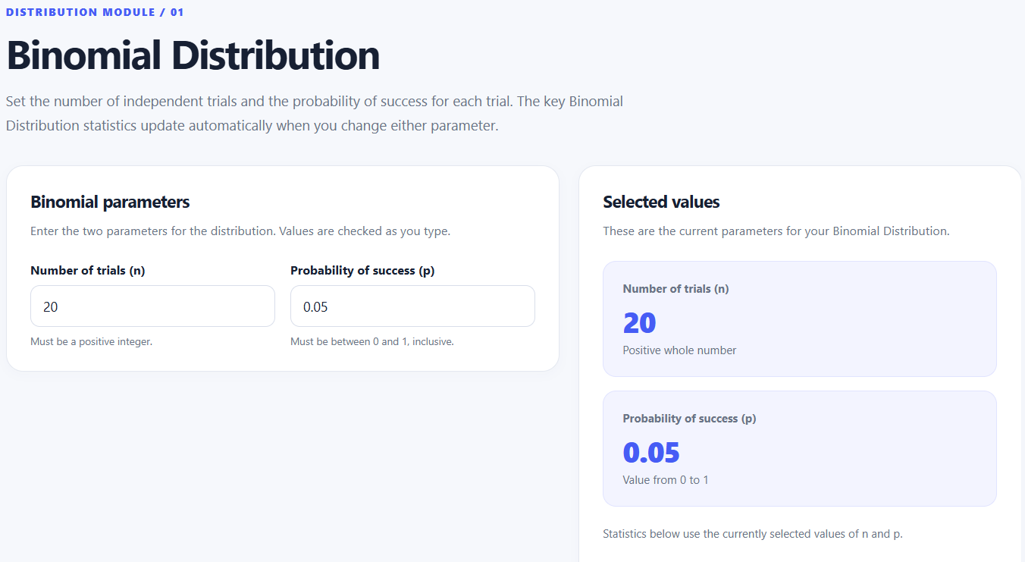
Ans 3:
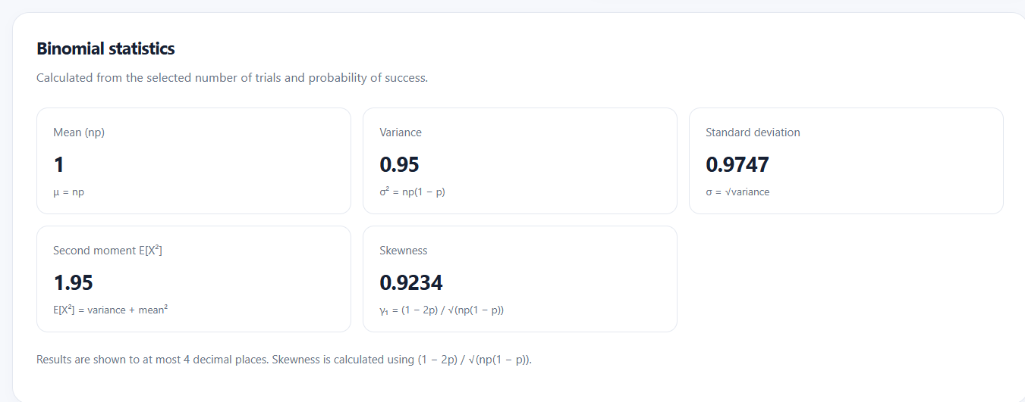
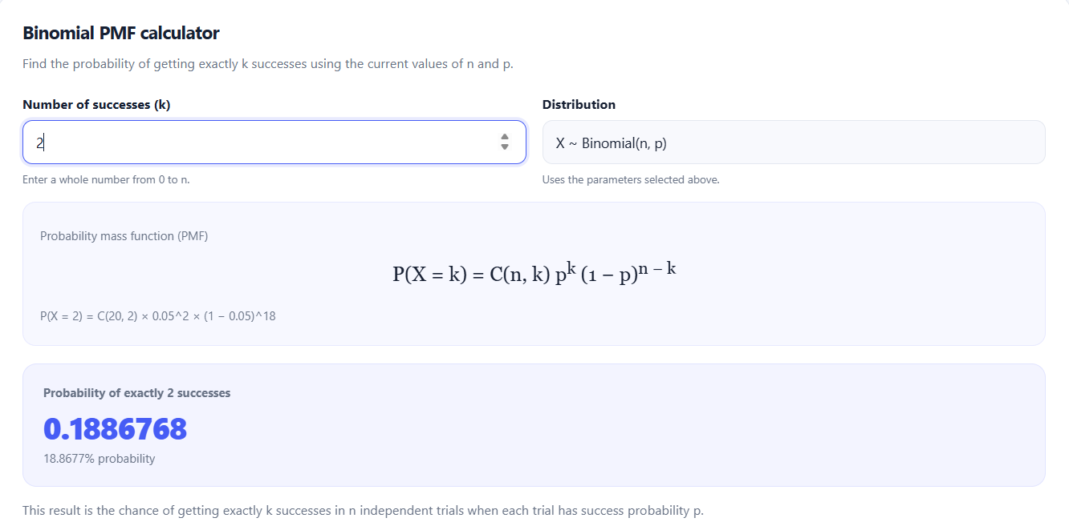
Probability of exactly 2 defects is where k=2

Ans 4: Number of success = Number of defects (x-axis) & Probability (y-axis)
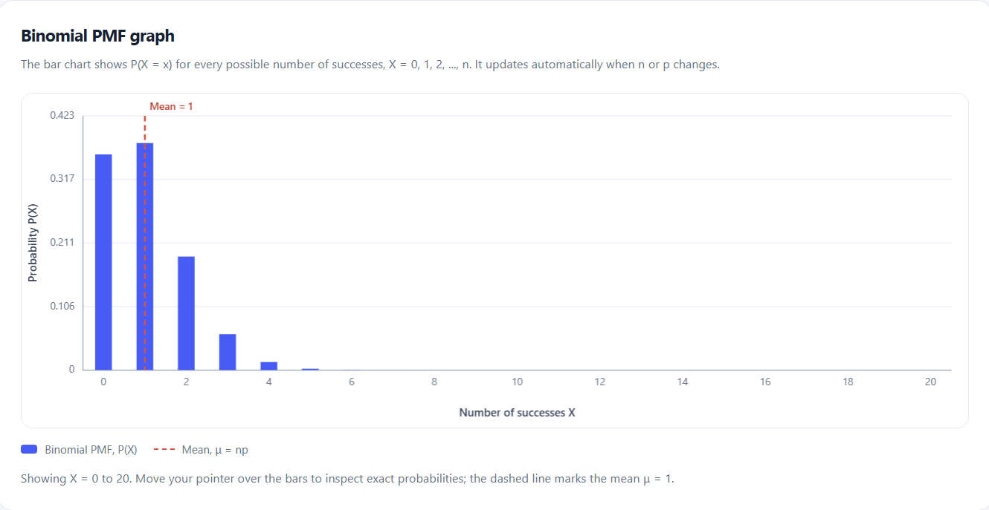
Ans 5: Probability of defect (p) changed from 0.05 to 0.10
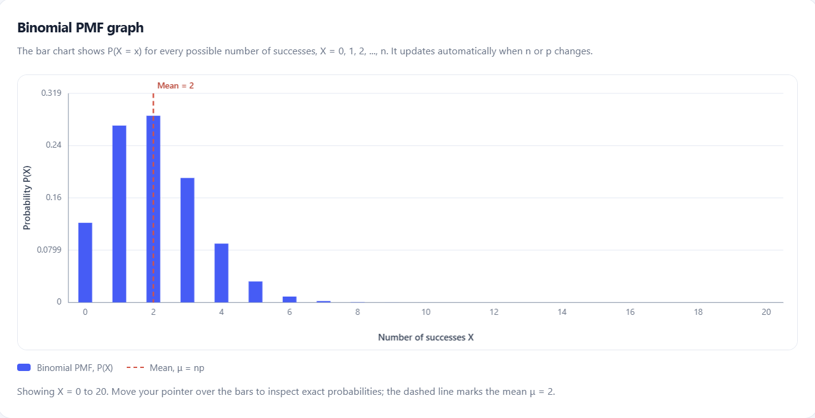
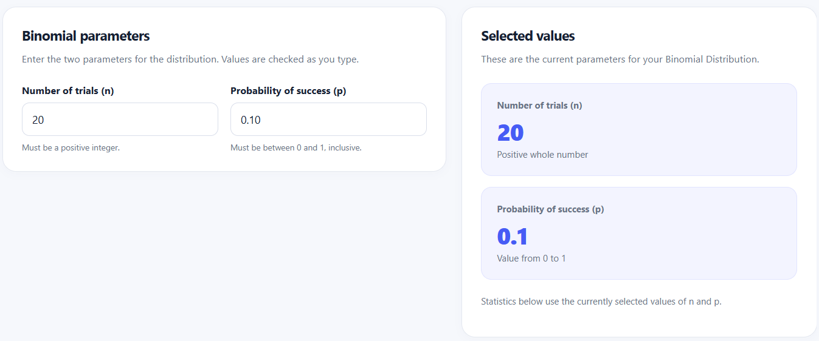

The distribution is highly right-skewed with highest peaks k=0 and k=1. After changing p to 0.1, new mean = 2 and the center of mass shifts to right.
So when we keep increasing the p value, the centre of mass keeps shifting right.
Ans 6: Lambda = 5 for 100 (n) inspected products and p = 0.05
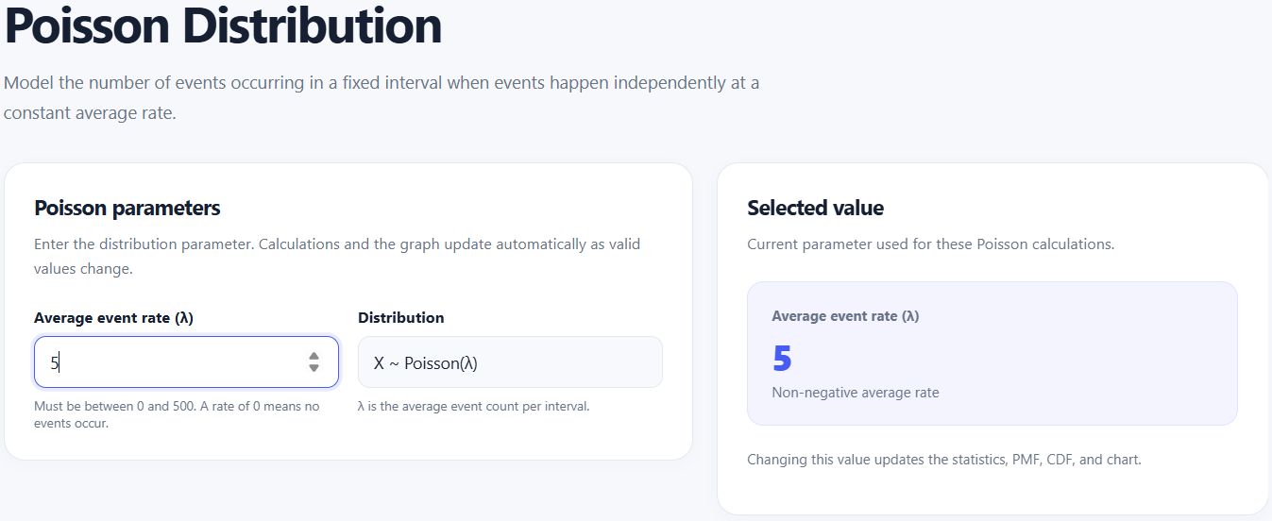
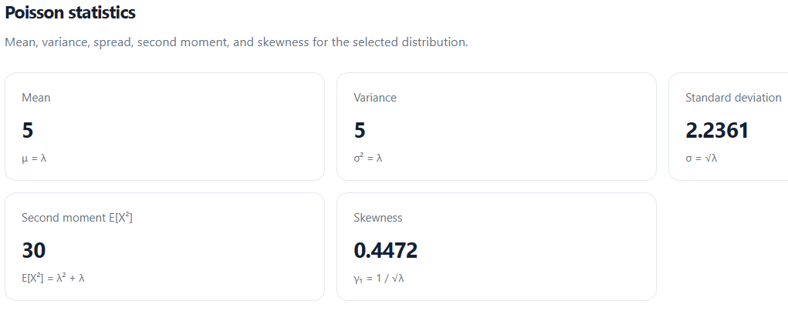
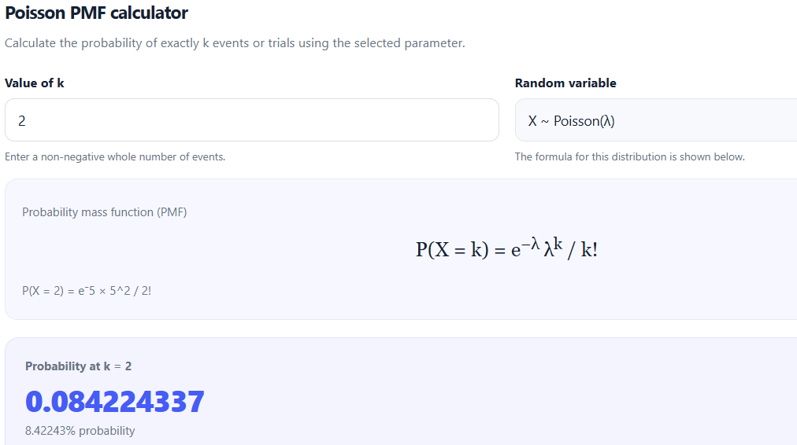
Comparison:
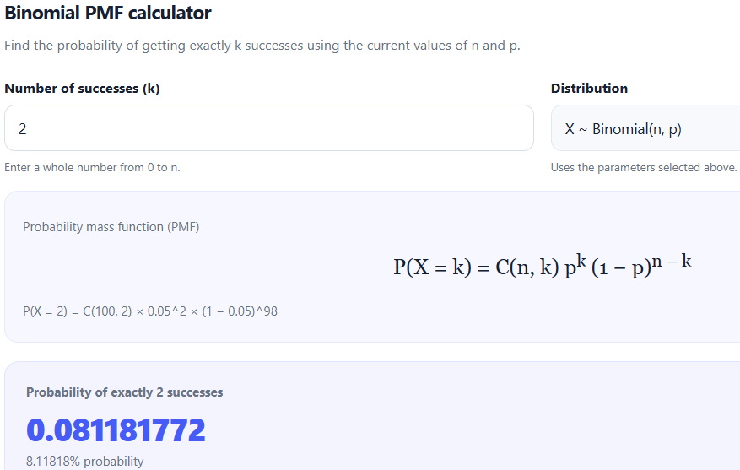

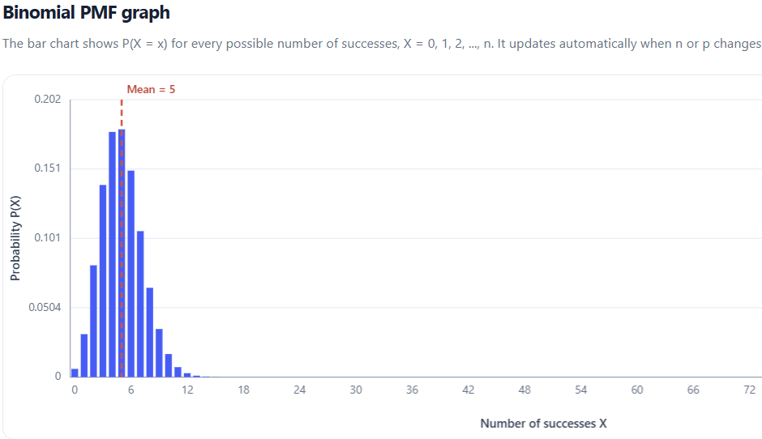
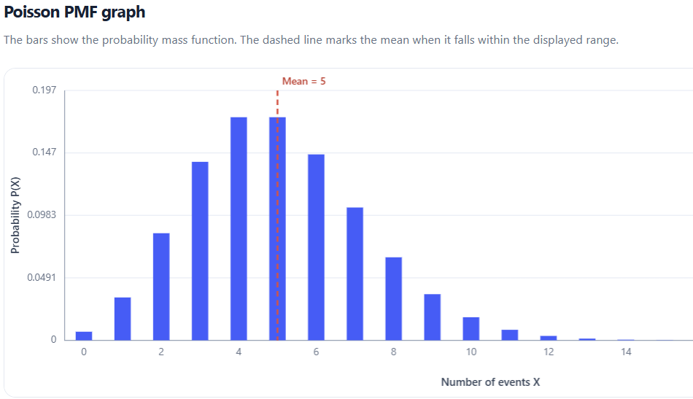

The PMF of Poisson and Binomial is approximately equal for given k values. Since n is large(100) and p is small(0.05), the Poisson distribution provides a simpler graph compared to the Binomial distribution.

Ans:7
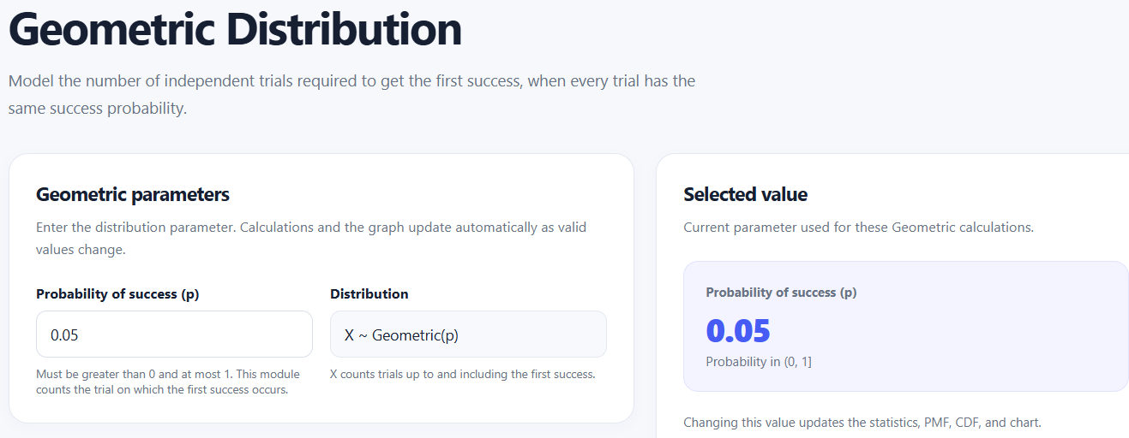
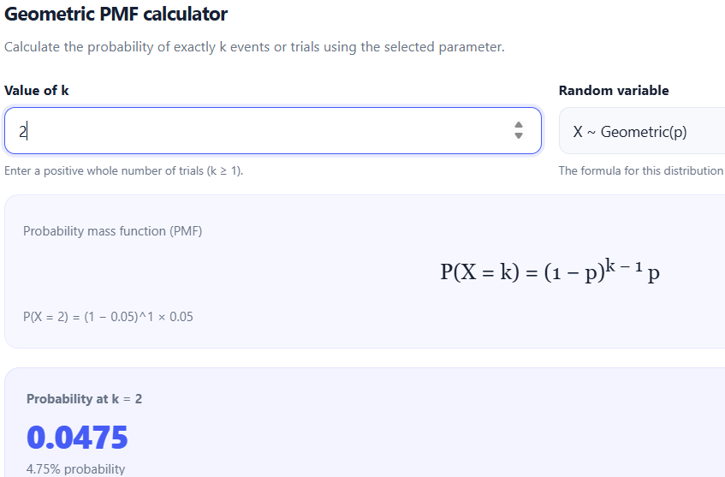
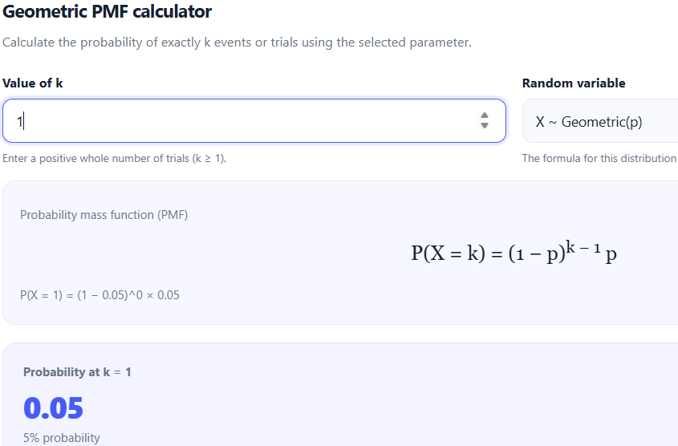

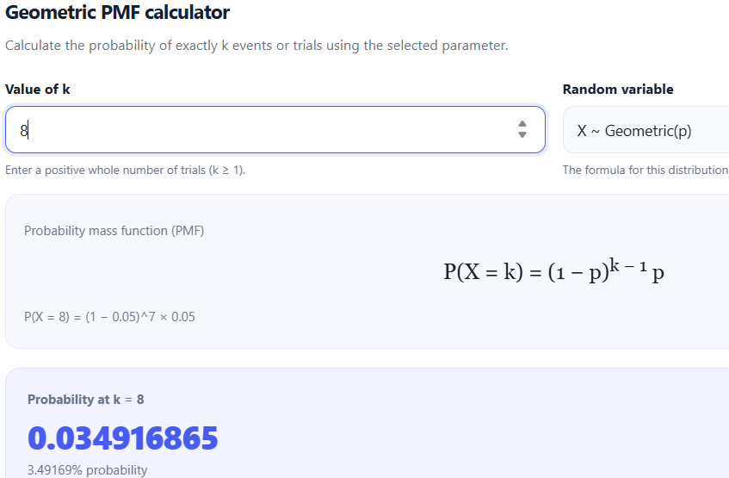
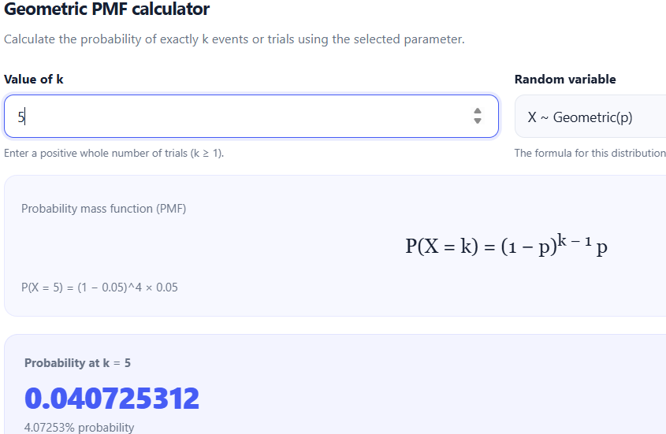

When we observe the Probability of defecting the first defect(k=1) is 0.05, then the next defect(k=2) is 0.04, so on which keeps decreasing as we increase the defect (k) value.

Ans 8: Quality-Control Inferences
​Acceptance Sampling & Sensitivity: In a small sample of 20 items at a baseline defect rate of 5%, there is roughly an 18.9% chance of observing exactly 2 defects, but a 1 - P(0) - P(1) ~= 26.4% chance of seeing 2 or more defects. If a quality threshold rejects a batch when >= 2 defects appear, over a quarter of standard batches would be rejected, suggesting thresholds must be calibrated carefully to avoid high false-alarm rates.
​Process Drift Detection: If the true failure rate doubles from 5% to 10%, the distribution rapidly shifts rightward, noticeably increasing the probability of multi-defect samples and making defects easier to catch in small lots.
​Inspection Efficiency: With p = 0.05, an inspector must check an average of 20 units before detecting a single defect. If non-destructive testing is costly, continuous monitoring via Poisson batch-sampling (lambda = 5 per 100 units) offers a more stable metric for monitoring process variance than item-by-item testing

